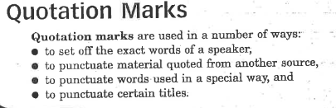
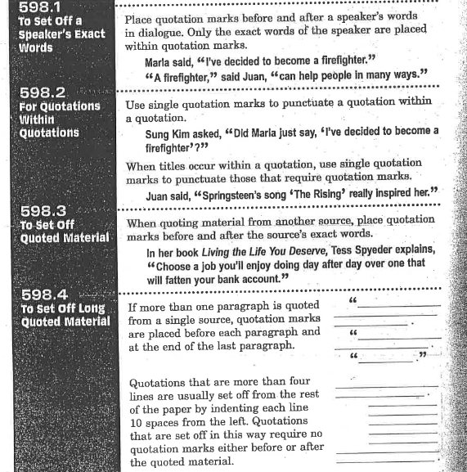

Using Quotation marks to...
- Punctuate some titles
- Show a speakers’ exact words

Directions: Add quotation marks where needed. If you are doing this digitally, put your quotation marks in a different color to help me give you feedback. Hint: Keep in mind whether the quotation marks need to be on the inside or outside of punctuation marks.

- Have you read the poem Spring Dragon?

- Caleb shouted, Hey, I saw your picture in the paper!

- My picture appeared in the article McCabe Scores in Finals.

- Duante couldn't get the song When Doves Cry out of his head.

- I have one suggestion for your short story Mama's Reading Lamp: Change the title.

- Today Dr. Nguyen is presenting his speech Get Fit! in the gym.

- Guillermo asked, Did you see The Smiths TV last night?

- This quarter we are reading Fahrenheit 451, the teacher said.

- I need to read the last chapter, Burning Bright, by the end of the month.

Using Quotation marks to...
- Punctuate some titles
- Show a speakers’ exact words
- To set off quoted material

Directions: Add quotation marks where needed. If you are doing this digitally, put your quotation marks in a different color to help me give you feedback. Hint: Not all of these need quotation marks.

- Principal Krenz announced, A hurricane is coming!

- Jamilah shouted, Next week the Hurricane Sisters are coming to our school! They're going to sing their new song, Eye of the Storm.

- David said, Did you just say, Next week the Hurricane Sisters are coming to our school? I can't believe it! They rock!

- Did you know there's a new book about them, too? Jamilah asked. Here, check this out. It's called Coast to Coast Hurricane.

- David read the following passage from the Hurricane Sisters' book:
The Hurricane Sisters, Jill and Lily, were actually
born during a hurricane. In August 1983, Hurricane
Alicia hit Galveston, Texas, and the twins' mother was
unable to leave the area before she went into labor.
Luckily, the birth was an uncomplicated one, and
mother and daughters rode out the hurricane together.

- He flipped a few more pages and read, Jill and Lily began singing at church picnics and talent shows at age three. By the age of six, both girls were learning how to play the guitar.

- David remarked, Wow! They've been performing together for years. Maybe that's why they've become so popular.

